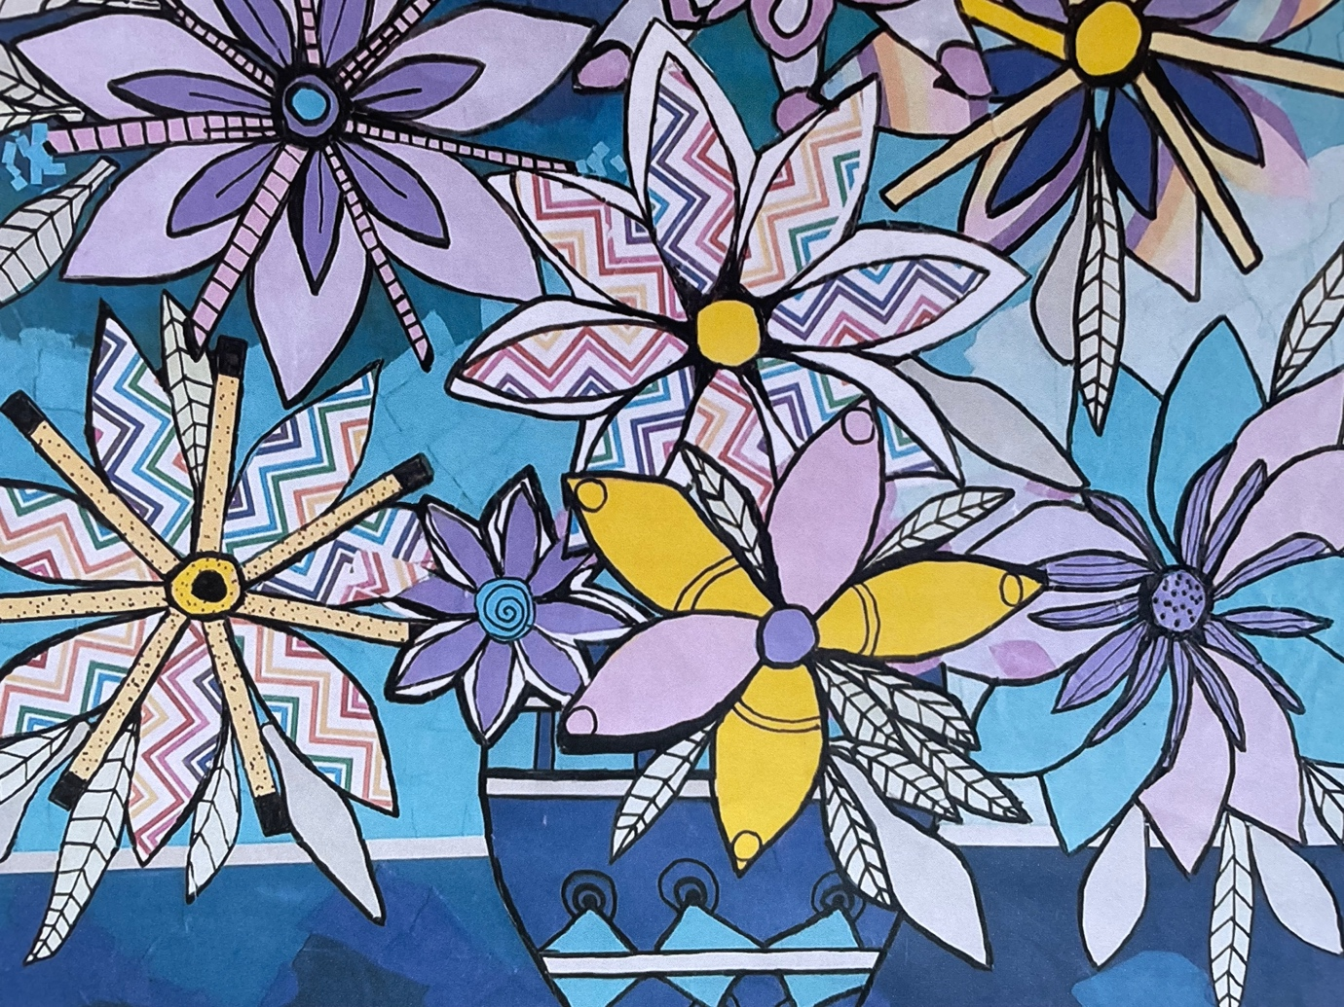

**Mixed Media by Erica Phillips**

**Showing at Pantechnica Gallery, York.**

**6th December 2024-5th January 2025**

**Opening night 6 December 6-8pm**

Erica Phillips is a new resident of York. In her youth, Erica was kept busy playing competition Netball and as a mother to four successful daughters. When the girls grew and moved away from home Erica turned to self-expression through art.

Self-taught, she began oil painting 20 years ago- this eventually transformed into mixed media using paper collage and inks.

Erica entered a portrait of John de Laeter, a scientist at Curtin University, into the 2010 Archibald Prize. He liked it so much he bought it and the portrait is now hanging in the science department at Curtin.

Erica’s work is bold and rich in colour. The Yupo paper has a magical way of getting the ink to move and keeps the colours vibrant. Her mixed media works include papers from a variety of sources, oil paint and alcohol inks.